#DIAGRAMS

1. ER DIAGRAM

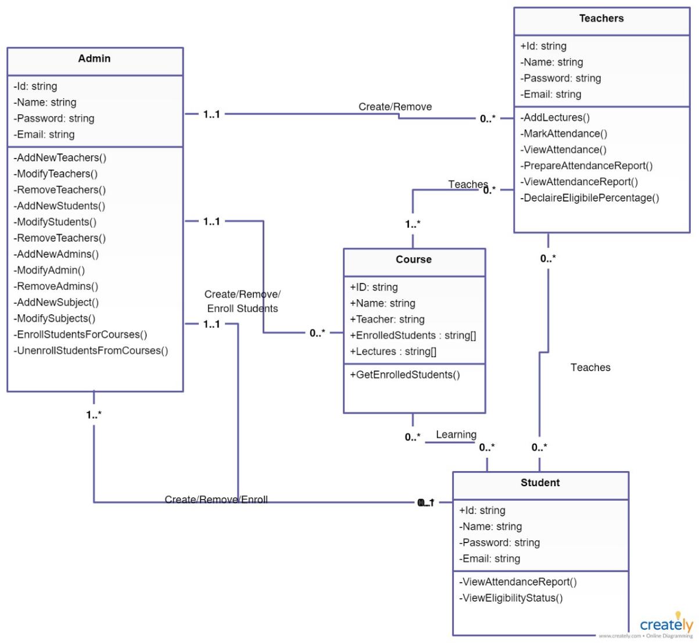

1. SYSTEM ARCHITECTURE

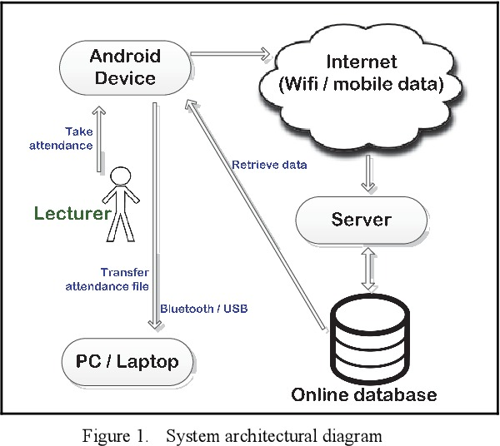

1. CONTEXT DIAGRAM

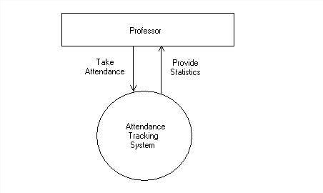

1. USE CASE DIAGRAM

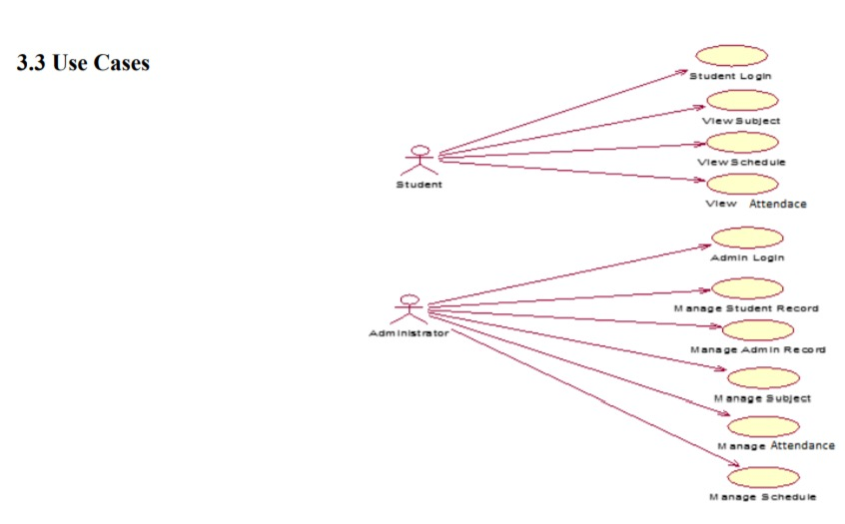

1. SEQUENCE DIAGRAM

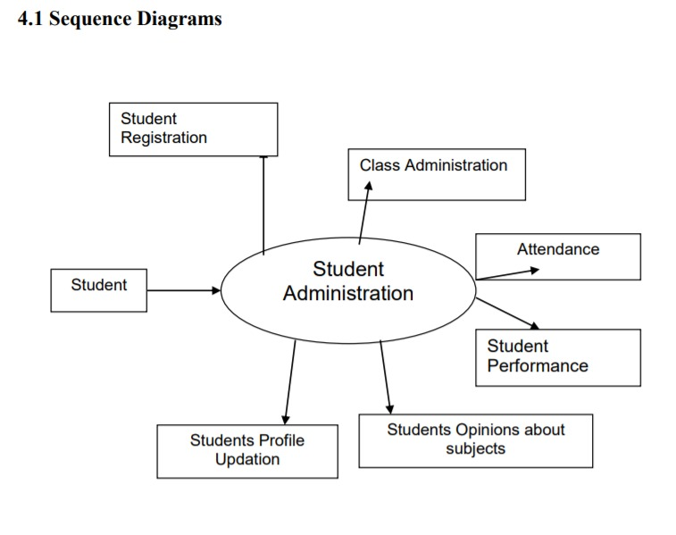

1. CLASS DIAGRAM

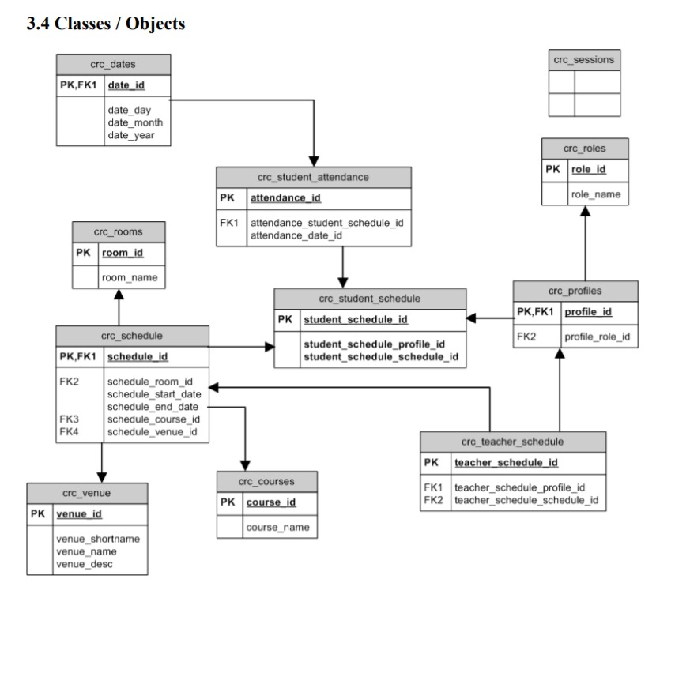

1. DATAFLOW DIAGRAM

